Historical Caravanserai's interior design criteria based on visual preference of travelers
Seyedeh Sarvin Farboud¹, Habib Shahhosseini^{2*}
1. Young Researchers and Elite Club, Tabriz Brach, Islamic Azad University, Tabriz, Iran
2. Assistant professor, Faculty of Art and Architecture, Tabriz Brach, Islamic Azad University, Tabriz, Iran
sarvinfarboud@yahoo.co.uk
Habib_shh@iaut.ac.ir

ABSTRACT
The purpose of this research is to investigate the travelers' visual preferences criteria in caravanserai hotels’ interior design to enhance human’s social, historical and cultural interactions. Using 356 questionnaires and Quantitative Research approach, the travelers' visual preferences of three hotels in Tabriz city are assessed. Photo questionnaires are prepared in accordance to the Information Processing Analysis theory and were examined by SPSS software. The result indicates that preferred caravanserai hotels include mystery variable with physical factors like medium intensity of light, warm and neutral colors, modern and traditional furniture integration, green space and wooden decoration. Interior architects can increase peoples’ interest of use in Caravanserai Hotels by considering the obtained results and its application in their design methods.

Keywords: Visual Preferences, Interior Design, Information Processing, Cultural Interactions, Caravanserai Hotels

1. Introduction
Conservation of historical buildings plays an important role in the sustainable development of old cities [1]. Heritage sites are now commonly viewed as having characteristics of an important asset, and their conservation should be assessed delicately [2]. One of the elements that gives identity to the heritage site is historical monuments, which are created using different techniques and materials [3] of construction, cultural and historical features. Considering the formation of cultures based on thinking, the thoughts of a society in a certain historical period are often fallowed in its historical monuments. The conversion of historical buildings to historical hotels is one of the best options for preserving cultural heritage against destruction. In the field of commissioning and exploitation, any kind of intervention in the historical monument is inevitable [4] and the revival of many historical regions and monuments requires protection and development under the supervision of an expert [5] and authorities.
Throughout history, many restorers and theorists believed the restoration of historical buildings to its original form and architecture is impossible [6], and in interior design as an important part of the architecture of the monument, imitation of the intrinsic state, while the basic principles governing the formation of the traditional building and the spirit of all the foregone works have not been fully understood, is impossible [7]. Unity cannot be achieved by combining fancy styles with the original style [8] and as Pietro Edwards emphasized: “it should later be possible to remove the integrations without damaging [9]”. Historical buildings as a cultural heritage, more than its "objectivities" and "antiquity", bear the "values and messages of humanity" and their conservation has always mattered [10].
The current research’s objective is to identify interior design criteria of historical hotels based on travelers’ preference and assessing the results with the restoration theories.
2. Environment Perception
The visual sense is the most important sense that captures and explains the elements of internal architecture and is able to see any images considering the attribute, characteristic, product, values, and ideas [11].
Vision, as the central component of human perception of the surrounding, helps human to understand the world [12]. It is asserted that the visual information dominates the culture and environment [13]. Therefore, visual characteristics have more decisive role in users’ preferences.
3. Applicable theories
Preference is a result of perceptions that originate from acquiring knowledge, innate interaction, and cognitive processing [14]. Visual preference is defined as an observer’s degree of like or dislike in terms of visual factors of a place or space [15]. Various theories [16, 17] have been developed to measure the visual preferences of the audience and can be used in a variety of disciplines (Table 1).

Table 1. Most frequently used Visual Preference theories
No | Theory | Researcher | Variable | Application
1 | Cognitive Analysis of Preference for Urban Spaces [16] | Thomas. R. Herzog | spaciousness, refuge, enclosure, coherence, legibility, complexity, mystery, typicality, age | Evaluation of urban spaces
2 | Evaluative image [17] | Jack L. Nasar | Naturalness, Upkeep, Openness, Historical Significance, Order | Evaluation of the quality of the visual environment and its impact on people's feelings and inferences
3 | Information Processing [18] | Rachel & Stephen Kaplan | Coherence, Legibility, Complexity, Mystery | Evaluation based on the human's need for information and his ability to process information
4 | Prospect and Refuge [19] | Jay Appleton | Refuge, Prospect | Evaluation based on the principle of life support

3.1. Information processing theory
One of the most utilized theories for the visual preferences is information processing theory [20] that can be utilized in order to examine visual preferences [21]; Therefore, this theory is an appropriate option for evaluating the preferential physical characteristics of travelers in the interior design of caravanserais and historic hotels. This theory is perceived as a cognitive development study approach and is based on the concept that mind is responsible for analyzing environment’s information; accordingly, humans process the information they receive rather than merely responding to stimuli [22].
It has been suggested that the human’s response to the environment can be divided into two basic aspects, namely, the attempt to understand and a tendency to explore [23]. According to this theory, the information, which is received from the environment, can be categorized into inferred and immediate levels [24]; Therefore, if two basic requirements are matched as the requirements of communicating with the internal space with two levels of information reception, four variables will serve as the predictors of the landscape aesthetics in the preferences matrix there [25-27]. The Theory of Information Processing variables are Legibility, Coherence, Complexity and Mystery which are defined separately in table 2.
According to the thematic literature, the initial roadmap for research is as follows (see figure 1).
Over the past 40 years, a large number of researchers have studied people's visual preferences [28-30] in different fields [31, 32]. Initial studies were on the characteristics of urbanization, which later became a source of research in fields such as computers [33], interior architecture [34, 35], and architecture [36].

Table 2. Definitions of information processing theory variables [37-39].
Variable | Definition
Legibility | It is clear when I can go in.  It is easy to get around every part.  It does not take much time to figure out the way of moving around.  I can always figure out where I am.
Coherence | Each component is well related to the others.  Components work well together.  Each component seems to hang together.  Each component helps the other to provide better comprehension.
Complexity | The scene has too many distractions, making it confusing.  The scene does not contain enough components to interest me.  The scene contains a good variety of components that keep me involved.  I feel drawn in by the variety of information or components the scene offers.
Mystery | The scene makes me feel there is something interesting to explore.  As I navigate through the scene, more curiosity inspires me.  I expect that the scene will provide an interesting thing to quench my curiosity as I explore around.  I feel I will find an interesting thing if I navigate more.

Figure 1. Initial Research Diagram

3.2. Applied Restoration and Conservation Theories in this Research
Various theories have been presented in relation to the way of dealing with historical buildings (Table 3), which, in terms of lexical semantic concept in the English language, conservation, restoration and operation of their subcategories may sometimes be perceived contrastively or synonymously. Therefore, their exact translation is not possible, and only with respect to the framework of theorists in different texts could one distinguish between them.

Table 3. Most frequently used Restoration and Conservation Theories.
No | Researcher | Description
1 | Eugene Viollet-Le-Duc,  (1814-1879)  )Restoration ( | To restore a building is not to preserve it, to repair, or rebuild it; it is to reinstate it in a condition of completeness that could have never existed at any given time [40]. Principles: elimination of attached sections to the original structure of the building. Completion of building basis on the original architecture, preserving of ruined buildings [41, 42].
2 | Luca Beltrami,  (1854-1933)  )Restoration ( | Accordance to historical evidence about the establishment of its original form.  The restoration of the historical building will be exactly the same as following the layouts, which is similar to the shape and composition of the original historical building [43]
3 | Camillo boito,  (1836-1914)  )Restoration ( | He was able to substitute attention to the architectural concepts in restoration as a substitute for adherence to the forms - styles in the historical buildings being intercepted.  His eight important principles are:  1. difference of style between the new and the old;  2. difference of construction materials;  3. Suppression of profiles or decorations;  4. Exhibition of removed old pieces, installed next to the monument;  5. Incision in each restored [rinnovato] Piece of the date of restoration or of a conventional sign;  6. descriptive epigraph carved on the monument;  7. Description and photographs of the different phases of the work, placed within the building or in a place close to it, or description printed in a publication;  8. Notoriety [44].
4 | Cesare Brandi,  (1906-1988)  ) Restoration( | The restoration of aesthetic integrity should be based exclusively on the information found on the artwork or building, not on analogies to other works [10] therefore, any art as a special product of human thinking must be restored to its own unique knowledge [4]
5 | John Ruskin,  (1818-1900)  )Conservation ( | His romantic restoration is opposed to the Eugene Viollet-Le-Duc restoration thought and his belief about conservation is very important for distinction between conservation and restoration, and preservation of historical buildings. Any interference in historical buildings’ situation even elimination of any attachment (uncoordinated or coordinated), or adding new segments for beauty or strengthening the historical building is ruled out [6].
6 | William Morris,  (1834-1896)  )Conservation ( | Founder of SPAB= The Society for the Protection of Ancient Buildings; His principle in conservation is: conservative repair in historical building and its daily care [45].

4. Caravanserais, as Historical Hotels
Caravanserai were initially rest places for people, their goods and animals, travelling between cities, and were often provided by the state [46]. Interior architecture of caravansaries inherently have a lot to say about that era’s history, culture and traditional structure. Although in the related studies of caravansaries, many of the historical and structural features are available in various history and travel books, the way of communication with the audience has been less focused on. Travelers' preferences are affected by many factors such as distinct insights of people about interior spaces resulting from their relationship with the space [14, 47] and various demographic variables such as ethnicity, education, and gender [48]. Some other researchers have also suggested that the sense of belonging [49], the symbolic aspect of the environment [50] and cultural differences [51] can affect users’ preferences.
Caravanserais are considered a place which have a potential to transform into historical hotels, although they lack sufficient design criterion regarding this purpose. Accordingly, the current research aims to identify these factors.
In the meantime, giving a new use to such historical building faces some challenges that need to be considered; post-occupancy evaluation (POE) is one of them [52]. A seven step POE process has been developed by HEFCE which contains (1) identifying the need for the need for evaluation; (2) deciding on the approach; (3) providing a brief for the POE; (4) planning the POE; (5) applying the POE; (6) preparing for the report; (7) taking action according to the POE results [53].

5. Research method
Quantitative research approach has been used to determine the visual preferences of travelers about historical hotels’ interior design factors. This study is based on "systematic empirical research of social phenomena through the statistical calculation method" [54].
The random sampling method was used to develop photo questionnaires catalog which is considered to be a valid surrogate for the real environment [55]. Out of a total of 1500 selected interior photographs from official websites of selected hotels, 200 items were chosen. A Panel of 15 experts divided 200 selective photographs based on the definitions of information processing variables (legibility, Coherence, complexity and mystery) which are described in table 2. After prioritizing, 8 photographs with the highest score were selected for each group, leaving 32 final photographs.
In presentation of the photo questionnaire booklet, it was carefully considered to not use similar group of variables on a single page and to avoid placing more than eight photographs on each page. Likert Scales’ 5-point spectrum has been used with very low, low, moderate, high, and very high choices in order to assess the photos, Additionally a textual questionnaire about general visual preferences was developed in order to determine the most preferred physical factors of historical hotels interior environment.
Shahriar, Gostaresh and Tabriz Hotels located in Tabriz, Iran (fig 2) were chosen for the distribution of questionnaires as there is not any historical hotel within Tabriz city. A total number of travelers over a seven-week period (from 22/9/2017 to 11/11/2017) who stayed in the selected hotels and respondents’ numbers from each one is described in table 4. Total sample size which is 356, is calculated through Cochran formula [56].

Sample Hotels | Average number of travelers  (Min-Max) | Respondents’ number
Shahriar Hotel | 636 - 1354 | 117
Gostaresh Hotel | 805 - 1363 | 118
Tabriz Hotel | 835 - 1393 | 121
Total | 2276-4110 | 356
Table 4. Sample size

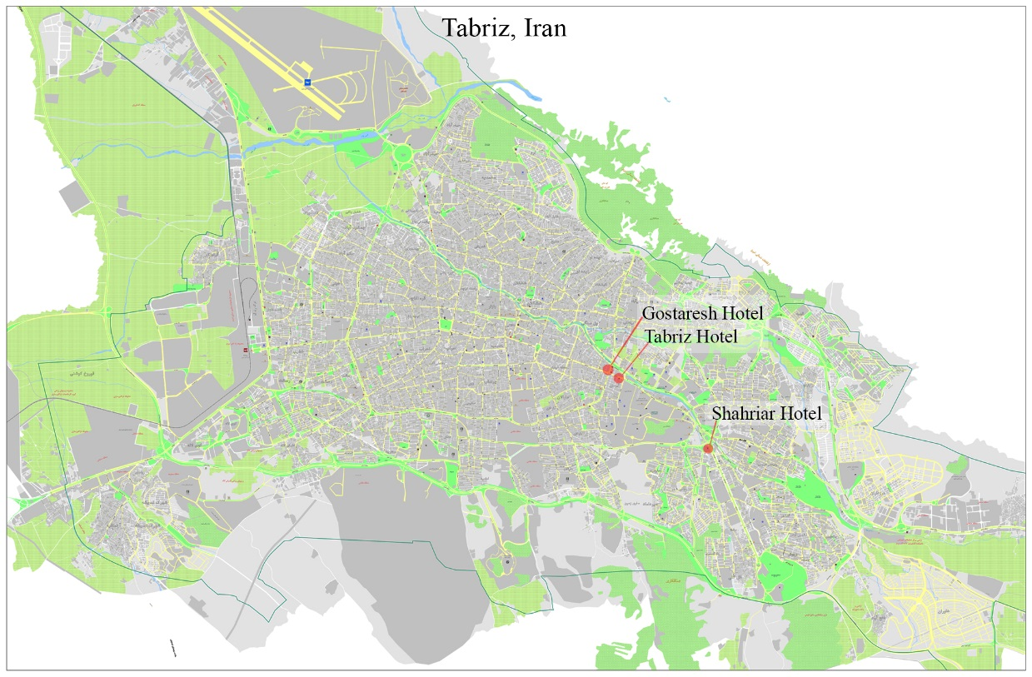
Figure 2. Samples Hotels’ location

After conducting the pretest, a valid questionnaire was distributed among Iranian travelers aged over 18 [57] and non-artist [58-60] with random sampling method. Data were analyzed using SPSS 22 software. Cronbach's alpha was calculated to test reliability, which turned out to have internal consistency [61]. After analyzing the results, the most and the least preferred information variables were identified (see figure 3).

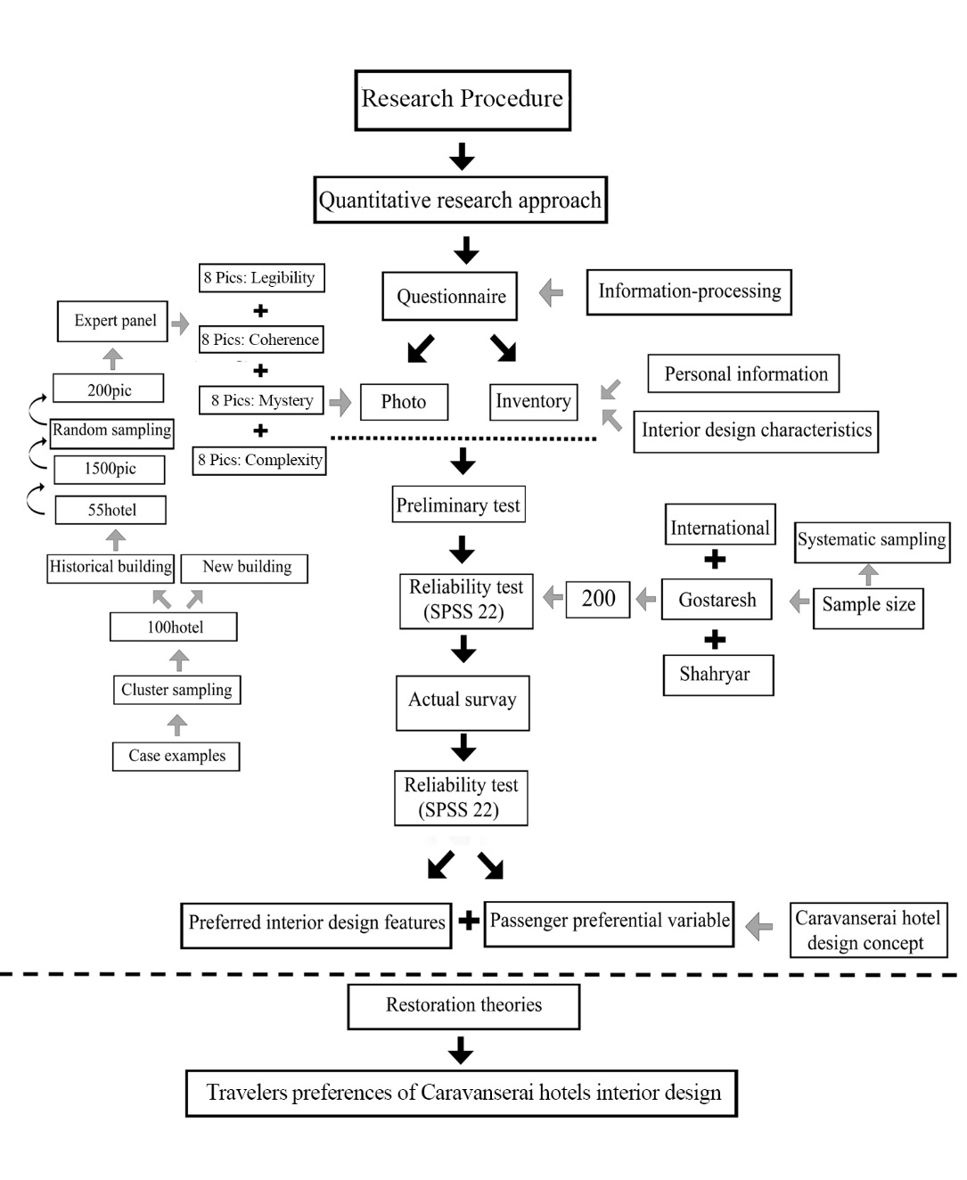
Figure 3. The Research Design

6. Results
The results showed that the Mystery variable with the highest mean average (3.73), is the most preferred and Complexity with the lowest mean average (3.11) is the least preferred by travelers in the caravanserai Hotels, while there is only a little difference between Legibility (M: 3.62) and Coherence (M: 3.61) (Table 5, figure 4). The results of inventory questionnaire in terms of interior design characteristic are shown in figure 5.

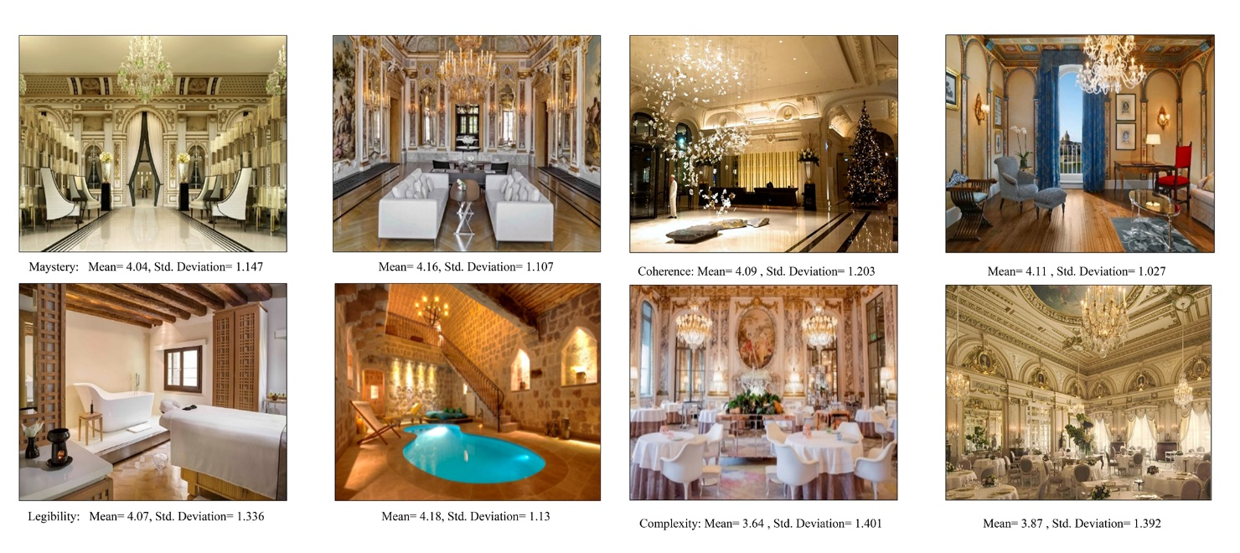
Figure 4. Preferred photographs of mysterious, legibility, coherence and complexity variables with the highest average

Figure 5. Inventory questionnaire results about preferred physical factors of historical monuments that have turned into hotels

Rank | Variable | Mean | S.D. | Cronbach’s Alpha | Space Configuration in historic hotels spaces
1 | Mystery | 3.73 | 1.367 | 0.691 | Several paths, rhythms and vague repetition, stone material, wood, plaster and brick composition, neutral and warm colors, indirect and hot lighting, ambiguity in the mind of the viewer with space separation by lattice panels
2 | Legibility | 3.62 | 1.135 | 0.692 | Open and transparent space, rhythm and repetition, stone material, plaster, bright flooring, bright colors, direct lighting
3 | Coherence | 3.61 | 1.253 | 0.738 | Open and transparent space, regular rhythm and regularity, stone material, ceramics and glass, bright flooring, bright and proportional colors, direct lighting
4 | complexity | 3.11 | 1.478 | 0.857 | Irregular rhythm and repetition, Various materials (stone , glass, ceramics, concrete and plaster), dark flooring, dark, bright and diverse colors, direct and indirect lighting
Table 5. The final results of the travelers’ visual preferences of interior space in historical hotels.

7. Discussion
According to Wood Cock and Hagerhall [62, 63], the most important variable of visual preferences is the mystery. In many studies of various fields, researchers such as Herzog, Ikemi achieved results consistent with this study [64-66]. Many researches have been conducted about the assessment of visual preferences of travelers [67-69]; A recent paper demonstrated that male guests prefer rooms decorated in masculine colors, while women are equally satisfied with masculine or feminine color schemes; also older travelers show equal satisfaction with contemporary and traditional style hotel rooms which is consistent with the current paper’s results [48].
Current survey showed that modern historic hotels with wooden interior decoration, fusion-style furniture (modern + traditional), neutral and warm colors in fusion forms (curve + Linear), moderate intensity diffused lighting, high green space, with a mysterious concept is more preferred by travelers (fig 5). The demand for green space in historical hotels is consistent with previous studies on the positive impact of green space on people's health [70-73]. Considering the different strategies for restoration of the historical buildings, the results of the visual preferences obtained from this study are in alliance with the theories of Viollet-le-Duc, Luca Beltrame, Camillo Boito and Cesare Brandi (see fig 6) to convert the historical buildings into hotels through the restoration of building and applying the preferred interior design criteria of travelers, although these results are against the mortality principle of John Ruskin (see table 3) [4, 6, 41, 44, 74].

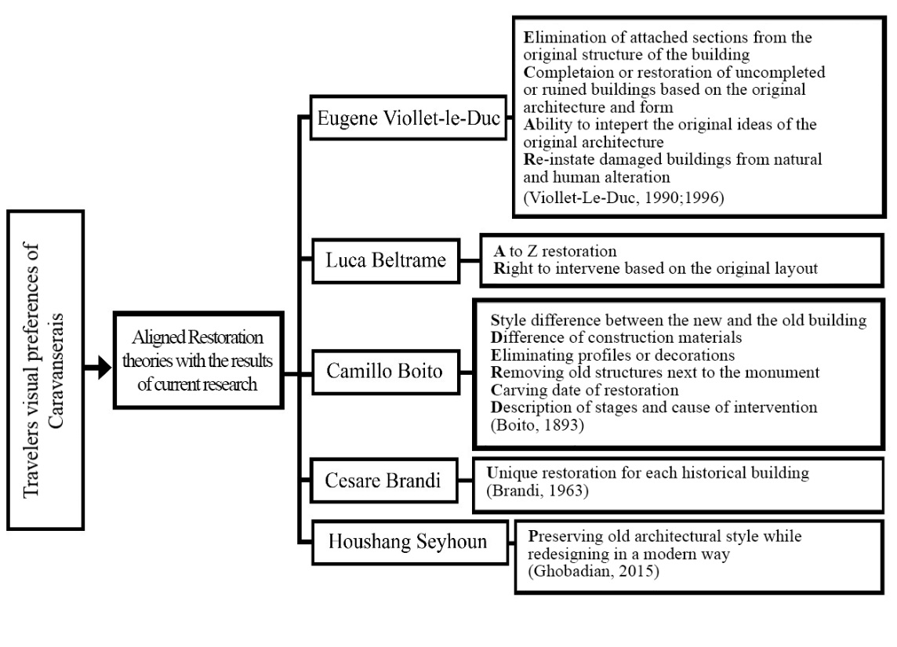
Figure 6. Aligned Restoration theories with results of current research

8. Conclusion
To give a chance of re-surviving to a historical building, that even a little not-well-considered decision will have irreparable consequences, requires close attention. The results of this research can help protecting historical monuments which are wasting a part of the city space but could meet the needs of today's society. That is to say, the rejuvenation of caravansaries and historical buildings to preserve them for the next generations is an attention-worthy subject.
The present study analyzed travelers’ visual preferences of historical Caravanserais in terms of interior space criteria. According to the results of a photo questionnaire, travelers prefer mysterious historical hotels for their stay, while hotels with confusing details of interior spaces are the least preferred. In addition, the results of inventory questionnaire demonstrated preferred physical factors of historical Caravanserai's such as medium intensity of light, warm and neutral colors, modern and traditional furniture integration, green space and wooden decoration. Converting historical buildings to hotels will prevent them from turning into unsafe ruins in urban environment. In order to preserve the immortality of historical hotels, interior architects and restorers should work together to apply the visual preferences of travelers while restoring the remains of buildings in a reversible way.
Obtained results of the visual preferences of travelers are aligned with the restoration theories of Viollet-le-Duc, Luca Beltrame, Camillo Boito and Cesare Brandi; in this case reversibility and not damaging the original historical buildings are applicable.
Limitations
In the current research’ photo questionnaire, the pictures of historical hotels were not selected based on their architectural style and this is considered to be a limitation of research.

References:

[1] Afify A. Sustainable Conservation For Historical Buildings In Mediterranean Cities. Heritage Architecture Studies. 2018:301.
[2] Wright WC, Eppink FV. Drivers of heritage value: A meta-analysis of monetary valuation studies of cultural heritage. Ecological Economics. 2016;130:277-84.
[3] Tabibian S, Ghavami M. NEW HVAC SYSTEM IN RESTORATION OF HISTORIC BUILDINGS. Journal of Nature Science and Sustainable Technology. 2016;10(1):37.
[4] Brandi C. Theory of restoration: Istituto centrale per il restauro; 2005.
[5] ZAHARIZUBIR KJH, HUSSAIN NH, ISIP PF. Rejuvenating The Shophouse: Conservation Of Historical Buildings In Penang’s Unesco World Heritage Site. Heritage Architecture Studies. 2018:335.
[6] Ruskin J. The seven lamps of architecture: John B. Alden.; 1885.
[7] Pugin AWN. Contrasts: Burns & Oates; 1969.
[8] Mazaherian H, Shahteimori Y. International Approaches to New Constructions in Historic Context (Study of Theories and International Agreements). Naqshejahan-Basic studies and New Technologies of Architecture and Planning. 2012;2(1):7-18.
[9] Jokilehto J. History of architectural conservation: Routledge; 2007.
[10] ARZHMAND M, AMINPOOR A. THE ROLE OF RESTORER IN RESTORING MONUMENTS OF ISLAMIC CULTURE AND CIVILIZATION; A REVIEW OF RESTORATION APPROACHES IN RESTORATION KNOWLEDGE BASED ONHUMAN FACTOR IN RESTORATION. 2016.
[11] Lyons E. Demographic correlates of landscape preference. Environment and behavior. 1983;15(4):487-511.
[12] Yoon S-J, Park JE. Do sensory ad appeals influence brand attitude? Journal of Business Research. 2012;65(11):1534-42.
[13] Postrel V. The substance of style: How the rise of aesthetic value is remaking culture, commerce, and consciousness. New York: HarperCollins; 2003.
[14] Kaplan S. Aesthetics, affect, and cognition: Environmental preference from an evolutionary perspective. Environment and behavior. 1987;19(1):3-32.
[15] Cheng C-K. Understanding visual preferences for landscapes: an examination of the relationship between aesthetics and emotional bonding: Texas A & M University; 2010.
[16] Herzog TR. A cognitive analysis of preference for urban spaces. Journal of environmental psychology. 1992;12(3):237-48.
[17] Nasar JL. The evaluative image of the city. 1998.
[18] Kaplan S, Fitzpatrick G, Docherty M. Cognition and environment. 1982.
[19] Appleton J. Prospects and Refuges revisited. Environmental Aesthetics: Theory, Research, and Application. Cambridge University Press, Cambridge; 1988.
[20] Stamps III AE. Mystery, complexity, legibility and coherence: A meta-analysis. Journal of Environmental Psychology. 2004;24(1):1-16.
[21] Kaplan R, Kaplan S, Brown T. Environmental preference: A comparison of four domains of predictors. Environment and behavior. 1989;21(5):509-30.
[22] Simon HA. Information-processing theory of human problem solving. Handbook of learning and cognitive processes. 1978;5:271-95.
[23] Kaplan R, Kaplan S. The experience of nature: A psychological perspective: CUP Archive; 1989.
[24] Shahhosseini H, Kamal Bin MS M, Bin Maulan S. Visual preferences of small urban parks based on spatial configuration of place. Iran University of Science & Technology. 2015;25(2):84-93.
[25] Bell S. Landscape: pattern, perception and process: Routledge; 2012.
[26] Gifford R. Environmental psychology: Principles and practice: Optimal books Colville, WA; 2007.
[27] Ryan RL. Local perceptions and values for a midwestern river corridor. Landscape and urban planning. 1998;42(2-4):225-37.
[28] Sevenant M, Antrop M. Cognitive attributes and aesthetic preferences in assessment and differentiation of landscapes. Journal of Environmental Management. 2009;90(9):2889-99.
[29] Alpak EM, Özkan DG, Mumcu S, Özbilen A. Complexity, Historicity and Coherence: Preference and Quality of the Changes in the Urban Scene. The Anthropologist. 2016;24(3):762-77.
[30] Svobodova K, Sklenicka P, Vojar J. How does the representation rate of features in a landscape affect visual preferences? A case study from a post-mining landscape. International Journal of Mining, Reclamation and Environment. 2015;29(4):266-76.
[31] Najd MD, Ismail NA, Maulan S, Yunos MYM, Niya MD. Visual preference dimensions of historic urban areas: The determinants for urban heritage conservation. Habitat International. 2015;49:115-25.
[32] Noland RB, Weiner MD, Gao D, Cook MP, Nelessen A. Eye-tracking technology, visual preference surveys, and urban design: preliminary evidence of an effective methodology. Journal of Urbanism: International Research on Placemaking and Urban Sustainability. 2017;10(1):98-110.
[33] Park S-e, Choi D, Kim J. Critical factors for the aesthetic fidelity of web pages: empirical studies with professional web designers and users. Interacting with computers. 2004;16(2):351-76.
[34] Chen L-W. Interior design variables in shopping malls: a study of visual preference. 1991.
[35] Mousavi Samimi P, Shahhosseini H. Evaluation of resident's indoor green space preferences in residential complexes based on plants' characteristics. Indoor and Built Environment. 2020:1420326X20917436.
[36] Akalin A, Yildirim K, Wilson C, Kilicoglu O. Architecture and engineering students' evaluations of house façades: Preference, complexity and impressiveness. Journal of environmental psychology. 2009;29(1):124-32.
[37] Lee Y, Kozar KA. Designing usable online stores: A landscape preference perspective. Information & Management. 2009;46(1):31-41.
[38] Mumcu S, Duuml T. Prospect and refuge as the predictors of preferences for seating areas. Scientific Research and Essays. 2010;5(11):1223-33.
[39] Ramanujam P. Prospect-refuge theory revisited: A search for safety in dynamic public spaces with a reference to design. 2007.
[40] Guzmán-Torres Z. Historic buildings and contemporary additions: the elements of a cohesive design relationship. 2009.
[41] Viollet-Le-Duc E-E. The Foundations of Architecture: Selections from the Dictionnaire Raisonné (1854), KD Whitehead (trans.), New York: George Braziller. Inc; 1990.
[42] Stanley-Price N, Price N, Talley MK, Vaccaro AM. Historical and philosophical issues in the conservation of cultural heritage: Getty Publications; 1996.
[43] Beltrami L. La Certosa di Pavia: Con 70 incisioni, e 9 tavole: U. Hoepli; 1895.
[44] Boito C. Questioni pratiche di belle arti: restauri, concorsi, legislazione, professione, insegnamento: U. Hoepli; 1893.
[45] Fawcett J. A restoration tragedy: cathedrals in the eighteenth and nineteenth centuries. The future of the past: attitudes to conservation, 1174-19741976. p. 74-115.
[46] O'Gorman K, Harvey C, Bryce D, O'Gorman KD, Baxter IW. Commerce, empire and faith in Safavid Iran: the caravanserai of Isfahan. International Journal of Contemporary Hospitality Management. 2013.
[47] Ho C-h, Sasidharan V, Elmendorf W, Willits FK, Graefe A, Godbey G. Gender and ethnic variations in urban park preferences, visitation, and perceived benefits. Journal of leisure research. 2005;37(3):281-306.
[48] Bogicevic V, Bujisic M, Cobanoglu C, Feinstein AH. Gender and age preferences of hotel room design. International Journal of Contemporary Hospitality Management. 2018.
[49] Galindo MP, Hidalgo MC. Aesthetic preferences and the attribution of meaning: Environmental categorization processes in the evaluation of urban scenes. International Journal of Psychology. 2005;40(1):19-26.
[50] Shahhosseini H. Influence of Non-visual Factors on Visual Preferences of Visitors to Small Urban Parks in Tabraz, Iran: Universiti Putra Malaysia; 2014.
[51] Zube EH. Themes in landscape assessment theory. Landscape Journal. 1984;3(2):104-10.
[52] Mundo-Hernández J, Valerdi-Nochebuena M, Sosa-Oliver J. Post-occupancy evaluation of a restored industrial building: A contemporary art and design gallery in Mexico. Frontiers of Architectural Research. 2015;4(4):330-40.
[53] HEFCE H. for E.(2006). Guide to post occupancy evaluation (p. 62). Higher Education Funding Council for England.
[54] Becker S, Bryman A, Ferguson H. Understanding research for social policy and social work: themes, methods and approaches: Policy Press; 2012.
[55] Steen Jacobsen JK. Use of landscape perception methods in tourism studies: A review of photo-based research approaches. Tourism Geographies. 2007;9(3):234-53.
[56] Cochran W. Sampling theory when the sampling-units are of unequal sizes. Journal of the American Statistical Association. 1942;37(218):199-212.
[57] Maulan S. Seremban urban park, Malaysia: a preference study: Virginia Tech; 2002.
[58] Rapoport A. The meaning of the built environment: A nonverbal communication approach: University of Arizona Press; 1990.
[59] Gifford R, Hine DW, Muller-Clemm W, Reynolds JR DAJ, Shaw KT. Decoding modern architecture: A lens model approach for understanding the aesthetic differences of architects and laypersons. Environment and Behavior. 2000;32(2):163-87.
[60] Bourassa SC. A paradigm for landscape aesthetics. Environment and behavior. 1990;22(6):787-812.
[61] Tabachnick BG, Fidell LS. Using multivariate statistics: Allyn & Bacon/Pearson Education; 2007.
[62] Woodcock DM. A functionalist approach to landscape preference. Landscape Research. 1984;9(2):24-7.
[63] Hagerhall CM. Clustering predictors of landscape preference in the traditional Swedish cultural landscape: prospect-refuge, mystery, age and management. Journal of environmental psychology. 2000;20(1):83-90.
[64] Herzog TR. A cognitive analysis of preference for field‐and‐forest environments. Landscape research. 1984;9(1):10-6.
[65] Herzog TR. A cognitive analysis of preference for urban nature. Journal of environmental Psychology. 1989;9(1):27-43.
[66] Ikemi M. The effects of mystery on preference for residential facades. Journal of environmental psychology. 2005;25(2):167-73.
[67] Li G, Law R, Vu HQ, Rong J. Discovering the hotel selection preferences of Hong Kong inbound travelers using the Choquet Integral. Tourism Management. 2013;36:321-30.
[68] Li G, Law R, Vu HQ, Rong J, Zhao XR. Identifying emerging hotel preferences using emerging pattern mining technique. Tourism management. 2015;46:311-21.
[69] Chang Y-C, Ku C-H, Chen C-H. Using deep learning and visual analytics to explore hotel reviews and responses. Tourism Management. 2020;80:104129.
[70] Kaplan S. The restorative benefits of nature: Toward an integrative framework. Journal of environmental psychology. 1995;15(3):169-82.
[71] Fuller RA, Irvine KN, Devine-Wright P, Warren PH, Gaston KJ. Psychological benefits of greenspace increase with biodiversity. Biology letters. 2007;3(4):390-4.
[72] Luck GW, Davidson P, Boxall D, Smallbone L. Relations between urban bird and plant communities and human well‐being and connection to nature. Conservation Biology. 2011;25(4):816-26.
[73] Harris V, Kendal D, Hahs AK, Threlfall CG. Green space context and vegetation complexity shape people’s preferences for urban public parks and residential gardens. Landscape Research. 2018;43(1):150-62.
[74] Ghobadian V. Shape of sustainable houses in Iran: a climatic analysis. European Online Journal of Natural and Social Sciences: Proceedings. 2015;4(3 (s)):pp. 110-20.

